Assignment - 29th January 2023- Questions

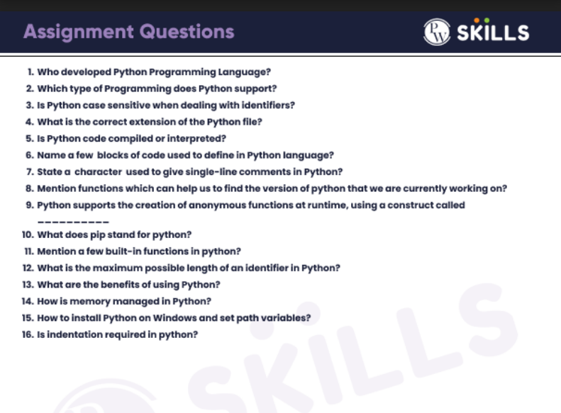

Assignment - 29th January 2023- Answers

1) Guido van Rossum

2) Object-oriented programming programming

3) Yes

4) .py

5) interpreted

6) i=input(“ Enter Number”)
Print(i)

7) #comment

8) python -V
(or)
import sys
print("User Current Version:-", sys.version)

9) Lambda

10) preferred installer program

11) len() , sorted(), reversed(), sum()

12) 79 characters

13) Presence of third-party modules /Extensive support libraries
Huge Open source community/ Easy to read and write

14) Python uses a portion of the memory for internal use and non-object memory. Another part of the memory is used for Python object such as int, dict, list, etc.

15) download python installer and install it and select the add python to path during installation

16) Yes

